CREDIT CARD DEFAULT

PREDICATION

Wireframe Documentation

AAKASH BHUTE

**1. On the initial page, a pop-up window will appear prompting the user to provide specific details, including gender, repayment status, bill amount, and other relevant information. This information will be utilized in the prediction process.**

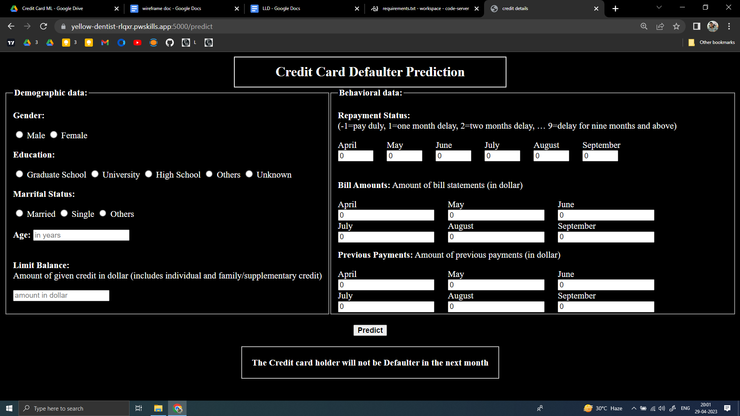

**2. If the user misses out on any input, the webpage will provide an alert message to ensure all the required information is entered.**

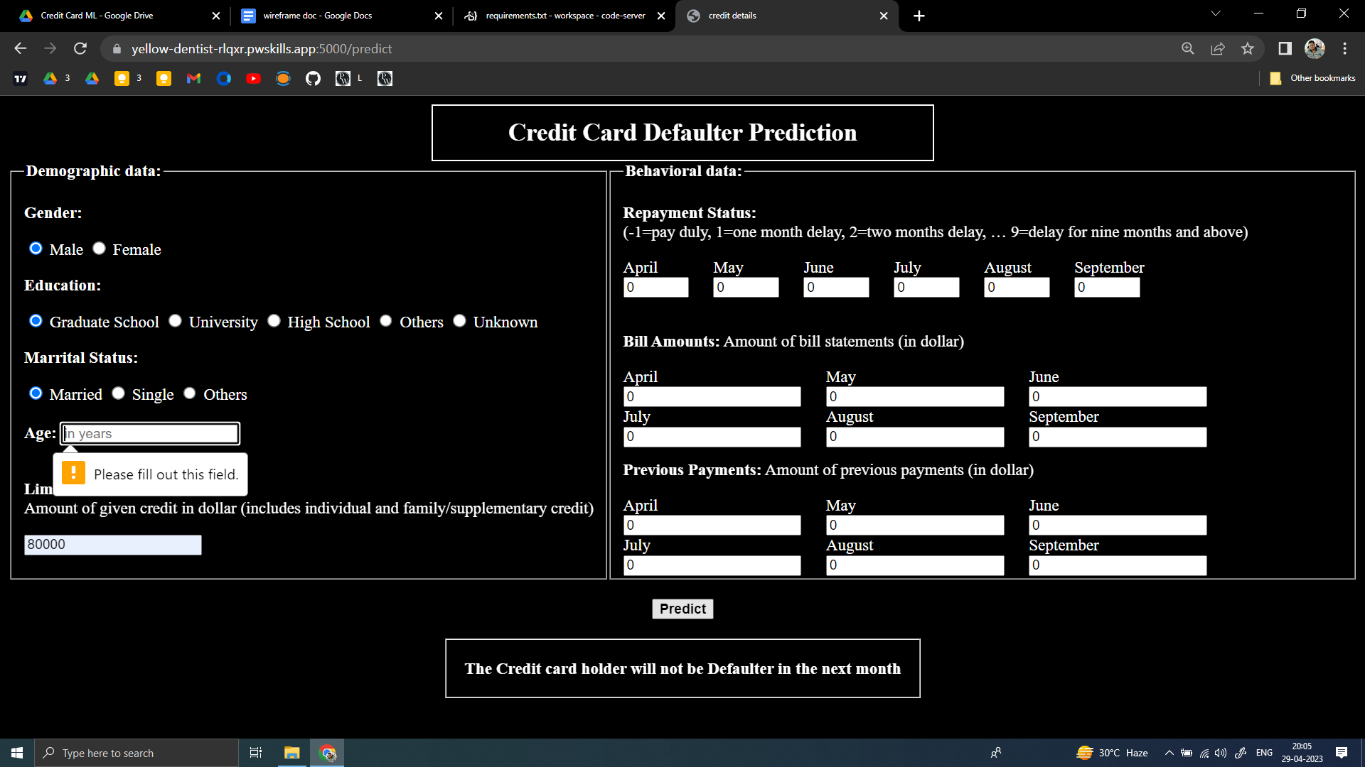

**3.After entering all the required information, the model will provide the prediction at the bottom of the page, indicating whether the borrower is likely to default on their credit card payment or not. For example, in this case, the model predicted that the borrower will not be a defaulter in the next month..**



**The prediction for this case is that the borrower will default on their payment in the next month.**

